Eight visualizations with Two tools

Bo Yang ([yang.6113@osu.edu](mailto:yang.6113@osu.edu))

D3 visualizations:

1.Bar chart (Hospital Capacity in Ohio):

Link: https://vizhub.com/LoganYangBo/8f322f2672ef48b8aa221e75398416b9data

choices :

Hospital Capacity

task choices :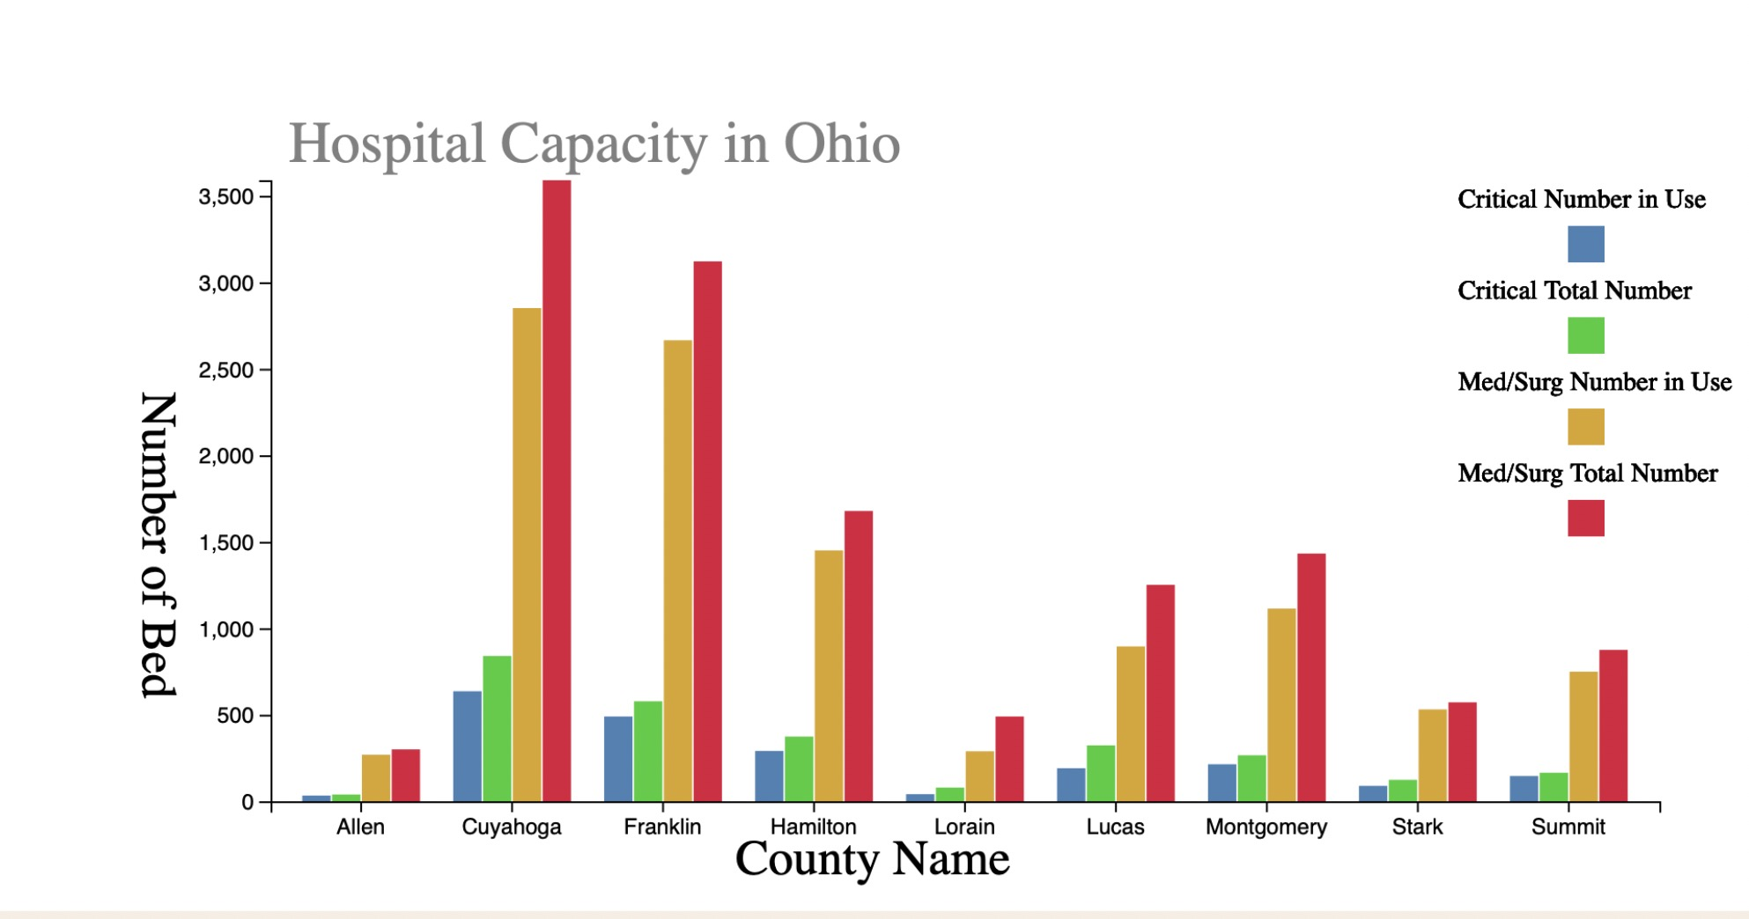

I want to directly visualize the use and total amount of various beds in each area in a bar chart. In this way, sick people can intuitively find out which district has more patients and which district has more beds available.

justification why good / bad tool :

I can freely manipulate each small rectangle and text, which is very convenient. Although the labels for the arrangement and coordinate axes of each group are automatically generated, much of the layout data still needs to be tried by ourselves, which is a little inconvenient.

Steps to produce my image:

1. index.js : csv() read csv data; common dimensions; margin data; scale declaration; draw axes; draw bars; draw legend
2. colorLegend.js : set l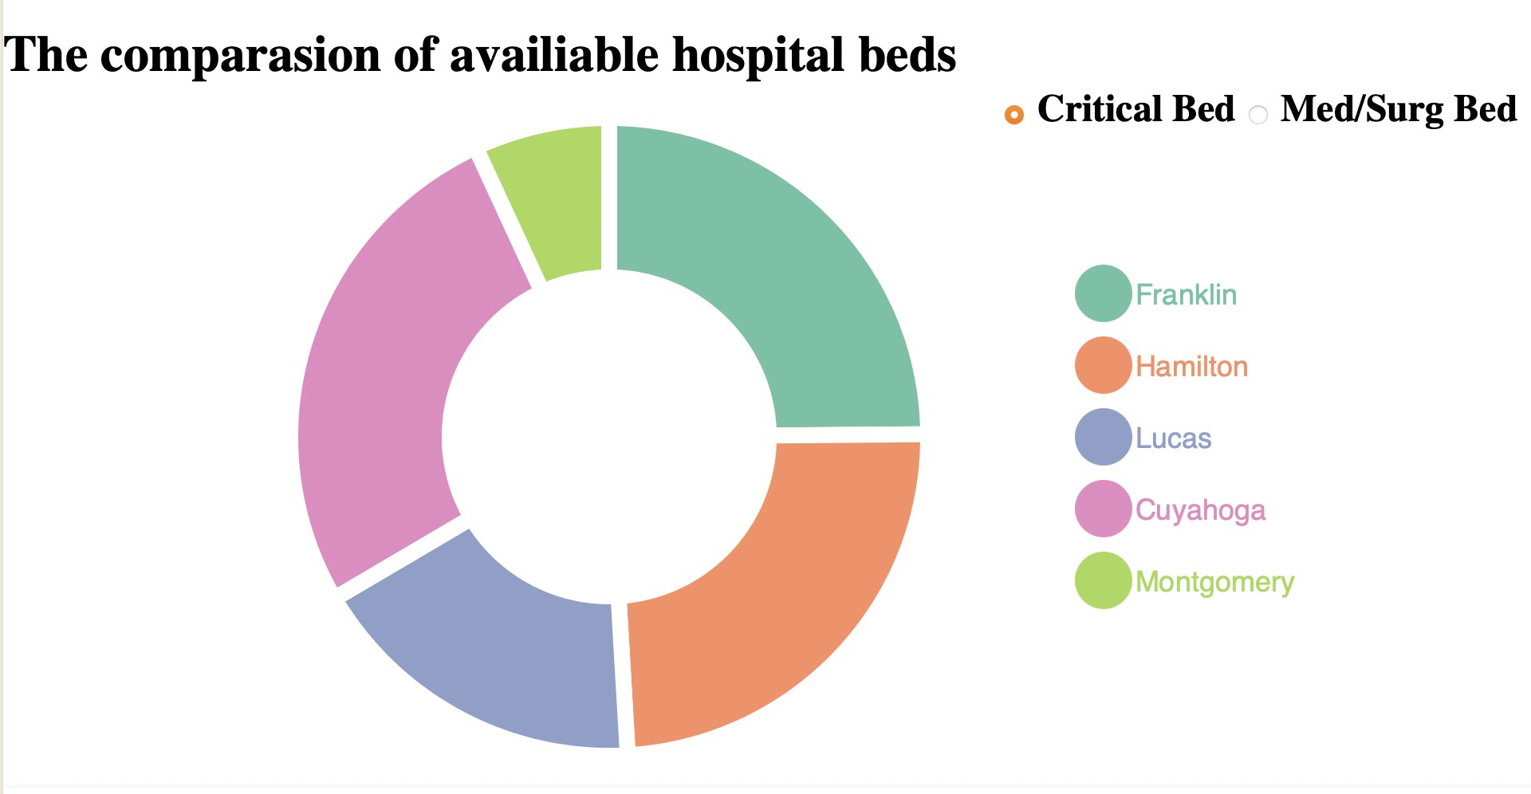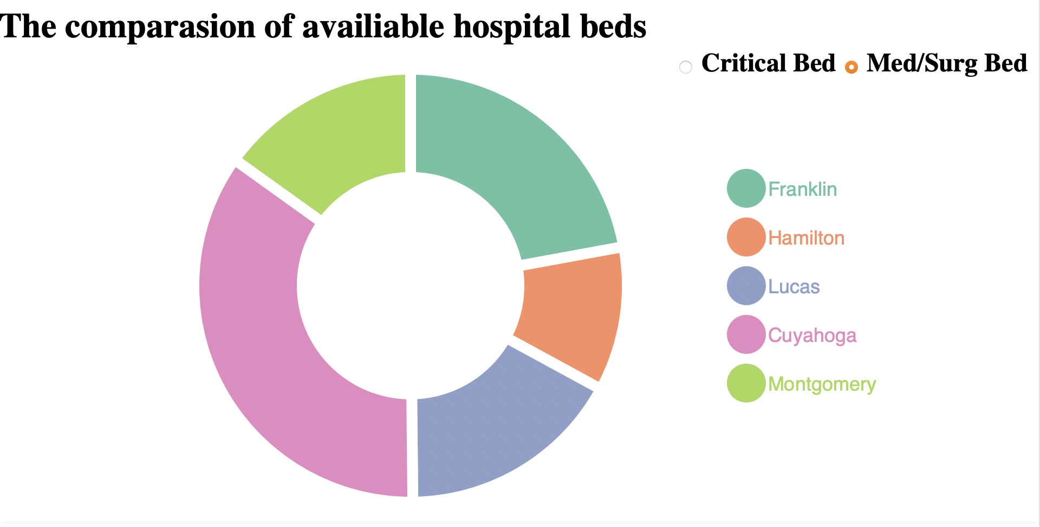egends’ position, class, color, text…
3. Index.html: write the page
4. Style.css: set the look

2.Pie chart (The comparison of available hospital beds):

Link: <https://vizhub.com/LoganYangBo/0a1810b2e29644f3ac4be34c6c8f92e7>

choices :

Hospital Capacity

task choices :

Patients can directly find the ratio of intensive beds and general beds remaining in each location.

justification why good / bad tool :

The update() function allows me to combine two graphs into one. Users can just update graph by clicking the button.

Steps to produce my image:

1. index.js : csv() read csv data; common dimensions; margin data; scale declaration; draw axes; draw bars; draw legend
2. colorLegend.js : set legends’ position, class, color, text…
3. Index.html: write the page
4. Style.css: set the look

3.Line chart (Everyday Cases for four Counties in Ohio):

Link: <https://vizhub.com/LoganYangBo/80ea1f551f2a4899acfe87ecc04ff7ad>

choices :

Cases of covid-19 in Ohio

task choices :

The analysts were able to directly se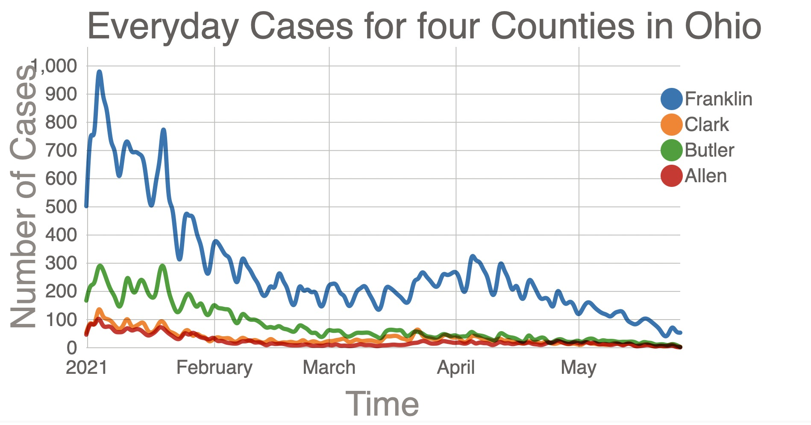e changes in the number of diagnoses in each of the four locations for each day in 2021.

justification why good / bad tool :

The date() function allows me to turn date data into date and then I can set the x-axis with the scale of date.

Steps to produce my image:

1. index.js : csv() read csv data; common dimensions; margin data; scale declaration; draw axes; draw bars; draw legend
2. colorLegend.js : set legends’ position, class, color, text…
3. Index.html: write the page
4. Style.css: set the look

4.Line chart (R(t) for Franklin & Ohio):

Link: <https://vizhub.com/LoganYangBo/a556c4b42ffd45839b39d873a7a5670a>

choices :

Cases of covid-19 in Ohio

task choices :

The analysts were able to directly see R(t) changes each day in 2021. And we can find the days’ r(t) above 1.

justification why good / bad 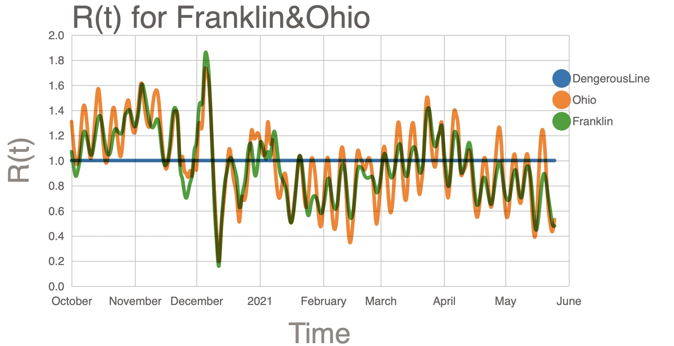tool :

The date() function allows me to turn date data into date and then I can set the x-axis with the scale of date.

Steps to produce my image:

1. index.js : csv() read csv data; common dimensions; margin data; scale declaration; draw axes; draw bars; draw legend
2. colorLegend.js : set legends’ position, class, color, text…
3. Index.html: write the page
4. Style.css: set the look

Matplotlib visualizations:

1.Bar chart (Hospital Capacity in Ohio):

choices :

Hospital Capacity

task choices :

I want to directly visualize the use and total amount of various beds in each area in a bar chart. In this way, sick people can 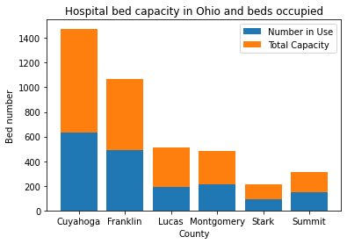intuitively find out which district has more patients and which district has more beds available.

justification why good / bad tool :

The drawing process is simple. Legend drawing is also automated. Just read the array and fill in the specified variables.

Steps to produce my image:

1. read data with pandas; turn date data into date
2. Set x and y axis; add legends requirements

3. Set plot requirements and show

2.Pie chart (The comparison of available hospital beds):

choices :

Hospital Capacity

task choices :

Patients can directly find the ratio of intensive beds and general beds remaining in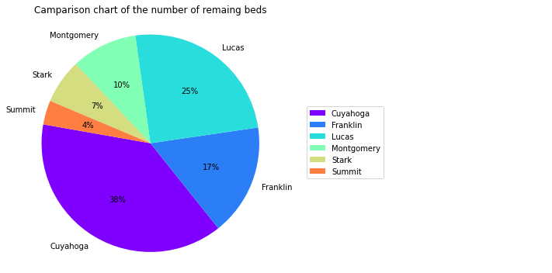 each location.

justification why good / bad tool :

The drawing process is simple. Legend drawing is also automated. Just read the array and fill in the specified variables.

Steps to produce my image:

1. read data with pandas; turn date data into date
2. Set x and y axis; add legends requirements

3. Set plot requirements and show

3.Line chart (Everyday Cases for four Counties in Ohio):

choices :

Cases of covid-19 in Ohio

task choices :

The analysts were able to directly see changes in the number of diagnoses in each of the four locations for each day in 2021.

justification why good / bad tool :

The drawing process is s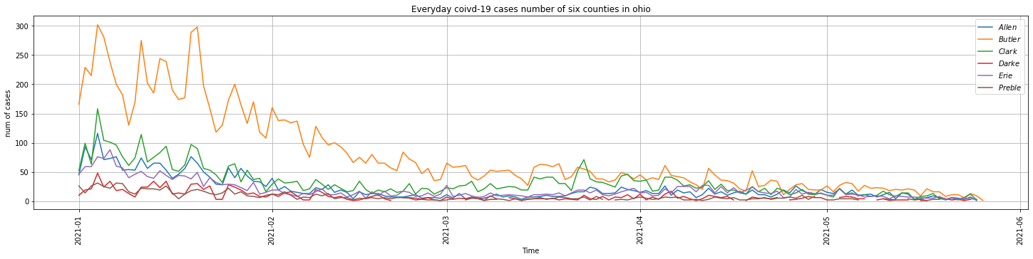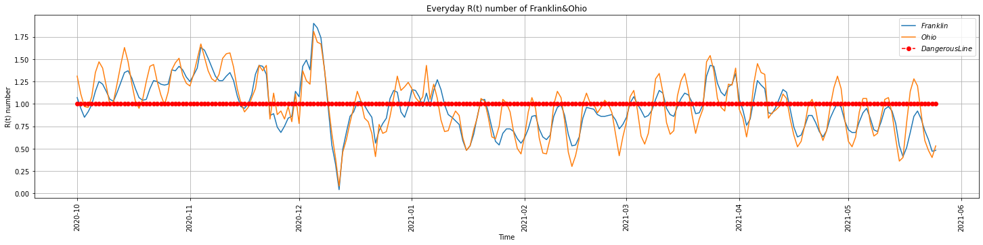imple. Legend drawing is also automated. Just read the array and fill in the specified variables.

Steps to produce my image:

1. read data with pandas; turn date data into date
2. Set x and y axis; add legends requirements

3. Set plot requirements and show

4.Line chart (R(t) for Franklin & Ohio):

choices :

Cases of covid-19 in Ohio

task choices :

The analysts were able to directly see R(t) changes each day in 2021. And we can find the days’ r(t) above 1.

justification why good / bad tool :

The drawing process is simple. Legend drawing is also automated. Just read the array and fill in the specified variables.

Steps to produce my image:

1. read data with pandas; turn date data into date
2. Set x and y axis; add legends requirements

3. Set plot requirements and show